# What Is ERC-6551 And Why Is Karst Building A Social Media Platform With It?

As the world becomes smarter, NFTs need to advance too. Traditional NFTs are very limited in their applications, which prevents them from being optimized for a lot of Web3 processes. So how do we create smarter NFTs capable of being more than digital art? The ERC-6551 protocol standard.

**What is ERC-6551?**

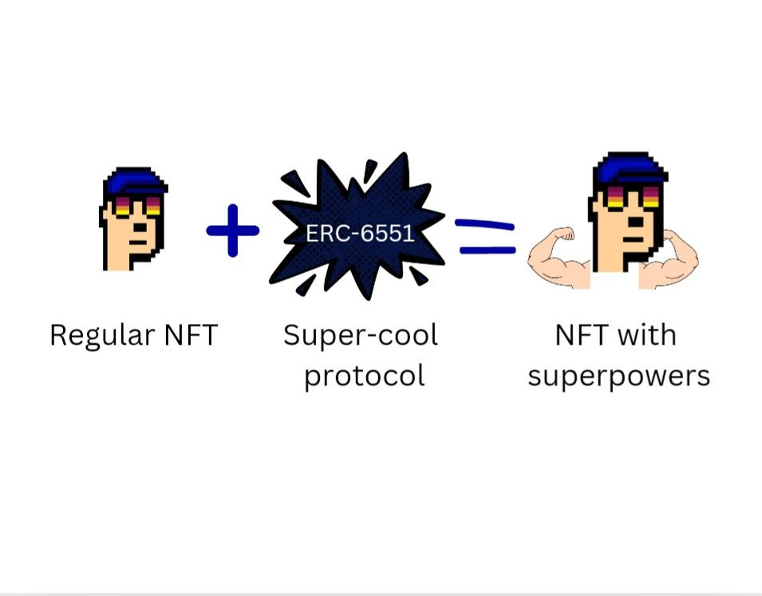

The ERC-6551 protocol is an extension of the ERC-721 standard, designed to enhance the functionality of NFTs by integrating smart contract capabilities.

This standard allows NFTs to carry out transactions and hold assets, transforming them into NFTs with ‘superpowers.’ Starknet, with its advanced Layer 2 scalability solutions, provides the perfect foundation for innovative projects like Karst.

## What can we do with the ERC-6551 Protocol Standard?

This enhanced protocol standard allows for:

* **Composable Media Structures:** This feature allows users to create and manage baskets of on-chain memes and other media, fostering a new era of creative expression within decentralized social media platforms.
* **Dynamic Content Interaction:** ERC-6551 enables NFTs to interact dynamically with content on decentralized platforms. For example, on Karst, NFTs can trigger actions such as voting, commenting, or unlocking exclusive content based on ownership criteria defined by the smart contract.
* **Multi-Token Integration:** ERC-6551 facilitates the integration of multiple tokens within a single NFT, allowing for complex asset structures. This capability is particularly useful in applications like decentralized finance (DeFi) where NFTs can represent collateral or governance rights across different protocols simultaneously.
* **Automated Asset Management:** With ERC-6551, NFTs can autonomously manage assets such as royalties or revenue shares. On Karst, creators can tokenize their content as NFTs with built-in revenue-sharing mechanisms that automatically distribute earnings to stakeholders based on predefined rules encoded in the smart contract.
* **Decentralized Social Media:** Platforms like Karst can leverage ERC-6551 to offer a decentralized social media experience where users have full control over their content, engagement, and digital assets.

### Why ERC-6551 Standard for Decentralized Social Media?

The ERC-6551 standard is preferred for decentralized social media platforms like Karst for several reasons:

* **Non-Invasive Integration:** ERC-6551 allows NFTs to become smart without requiring changes to the contract or complex user actions. This simplicity ensures a seamless user experience while enhancing NFT functionality.
* **Flexibility and Versatility:** Unlike other standards, ERC-6551 supports a wide range of functionalities without compromising on security or scalability. This versatility is crucial for platforms like Karst, where user engagement and asset management are paramount.

## What is Karst and how does it utilize ERC-6551?

Karst, developed and owned by Horus Labs, is a decentralized social graph built on Starknet designed to empower creators by allowing them to retain their content and audience. This helps users break free from algorithmic restrictions prevalent on many centralized social media platforms.

Primarily, Karst is created for content creators, influencers, and anyone looking to maintain control over their digital presence without relying on centralized platforms, harnessing the power of ERC-6551 to create Token Bound Accounts (TBAs), which serve as the backbone of its decentralized social graph.

Karst uses TBAs as user profiles that function as smart accounts, capable of holding and managing assets. By transforming user profiles into TBAs, Karst ensures that users have full control over their digital assets and interactions.

## How Karst Works:

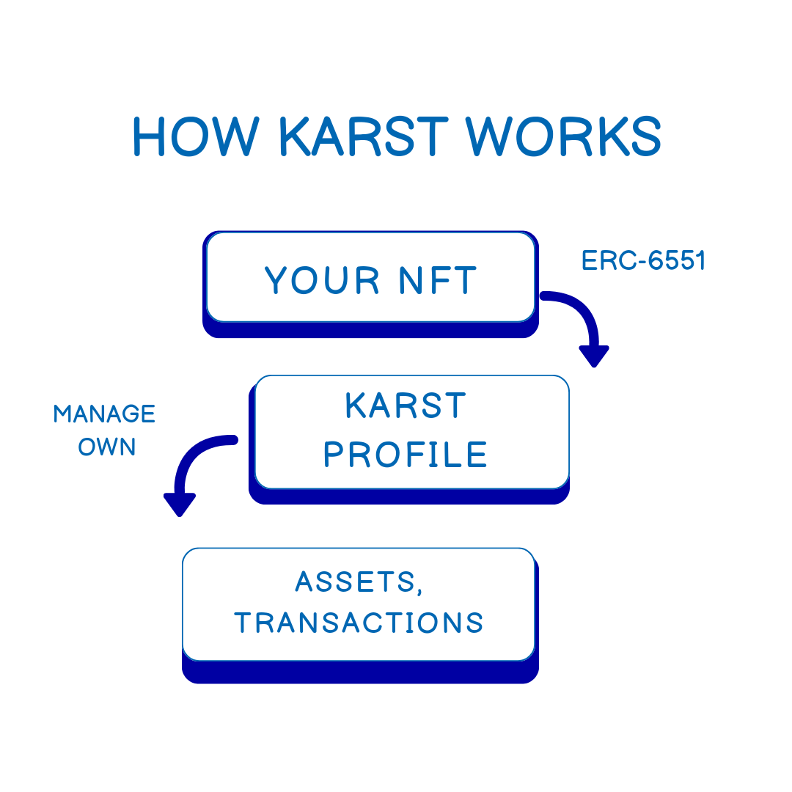

**Core Functionality**

Karst operates by allowing creators to manage their content and audience directly through token bound accounts (TBAs). These TBAs are created using the ERC-6551 protocol, an Ethereum Improvement Proposal (EIP) that endows NFTs with smart contract functionalities.

Users can conduct transactions and hold assets through their Karst profiles rather than traditional wallets. Importantly, TBAs do not have autonomy of their own; users must still approve transactions, ensuring that any assets associated with the Karst account remain under the user’s control.

When a TBA is deployed, it outputs a hexadecimal address, functioning as a regular wallet address connected directly to the user's Karst profile. The NFT from which the TBA was created continues to act as a wallet and is compatible with other NFTs.

**Technical Architecture**

The architecture of Karst includes several key components:

* **TBAs (Token Bound Accounts):** These accounts enable users to perform transactions and hold assets directly through their Karst profiles while maintaining user control. Profiles are TBAs by default, meaning they are smart accounts capable of holding assets.
* **ERC-6551 Protocol:** This standard is an extension of the ERC-721 standard and allows NFTs to function like smart contracts, adding a layer of utility and interaction to the NFTs.
* **Follow Operations:** These are tracked with NFTs and are customizable, allowing for unique social interactions.
* **Precalculated TBAs:** TBAs are precalculated per NFT using a specific set of mathematical conditions. Users simply deploy the TBA to transform their NFT into a fully functional account.
* **Registry Contract:** This contract supports TBAs on different chains by holding the methods to calculate the TBA of a given NFT, enabling future multi-chain support.
* **Starknet Integration:** By building on Starknet, Karst leverages the scalability and security benefits of ZK-rollups, ensuring efficient and secure operations.
* **Tokenbound Explorer:** This functions like a regular blockchain explorer, allowing anyone to view the assets contained within any TBA (Karst profile).

With Karst, user profiles are essentially smart accounts (TBAs), enabling users to hold assets directly within their profiles.

## Key Features of Karst:

**Scalability**

By utilizing Starknet’s ZK-rollup technology, Karst significantly enhances transaction throughput and reduces gas fees, making interactions smooth and cost-effective.

**Security**

The integration of TBAs and ERC-6551 ensures that transactions and asset management are secure, leveraging the robustness of smart contracts and the security of the Ethereum blockchain. Since TBAs require user approval for transactions, users retain control over their assets.

**Interoperability**

Karst’s use of standard protocols allows for seamless integration with other platforms and services, enhancing its utility and reach. The underlying NFTs are compatible with other NFTs, allowing for broader utility across different applications.

**User Experience**

The user interface is designed to be intuitive and user-friendly, making it easy for creators to manage their content and audience without technical barriers. Followers can mint and cherish posts as NFTs, adding a new dimension of interaction and value.

## Why Karst?

Karst has a unique approach to user control that gives users full autonomy over their accounts. This is expressed in three major ways:

**Access Control:** Karst profiles can control user access based on specific NFT ownership, enabling tier-based access systems with special benefits for members, such as exclusive content or event access, and even premium subscription models.

**Permissionless Innovation:** Karst’s token-bound technology is permissionless, meaning no single entity can control user accounts. This contrasts sharply with centralized platforms where accounts can be suspended or restricted based on community standards or policy violations.

**User Empowerment:** Users retain full control over their Karst accounts and assets, independent of external influences or restrictions. This eliminates concerns about arbitrary account suspension common on centralized platforms.

## What can you use Karst for?

**Content Creation and Management:** Creators can publish and manage their content directly on Karst, retaining control over their work and audience. They can also move their massive following across different social media platforms to their Karst profile.

**Content Monetization:** Through TBAs, creators can engage in direct transactions and monetization strategies without intermediaries. Followers can mint and cherish posts as NFTs, creating new revenue streams and engagement opportunities.

**Access Control and Customization:** Karst profiles (TBAs) can control user access based on specific NFT ownership. This allows. Karst profile owners create a tier-based access system, offering special benefits for members holding particular NFTs, such as exclusive content, access to exclusive events, or a premium monthly subscription model like Snapchat.

## Karst is creating magic with ERC-6551

Karst offers a decentralized, creator-centric social graph that leverages the power of Starknet and ERC-6551 to provide a secure and scalable platform for everyone. By allowing creators to manage their content and audience through TBAs, Karst breaks free from the constraints of traditional social media platforms.

Karst’s integration with Starknet and its utilization of the ERC-6551 standard represents a significant leap forward in the way we interact. Web3 is about decentralization, and Karst is championing that through decentralized social media.

To learn more about Karst and its innovative use of ERC-6551 on Starknet, read the official documentation [here](https://github.com/horuslabsio/karst-core).

## FAQs:

**Why do NFTs need smart contract capabilities?**

Traditional NFTs are limited in their application. TBAs, however, provide expanded functionality by acting as smart accounts that can hold and manage assets.